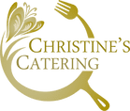
Ploughman’s Boxes

Selection of Cheeses
Our own Baked Ham
Slice of Scotch Egg
Sausage Roll
Crusty Roll & Butter
Baby Onions
Apple Chutney
Mixed leaves /Cherry Tomatoes
Apple

Including bamboo plates, cutlery and delivery

